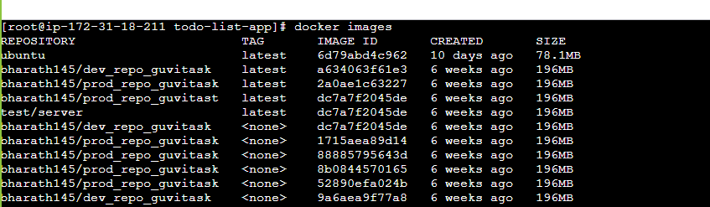

**Docker Container Commands :**

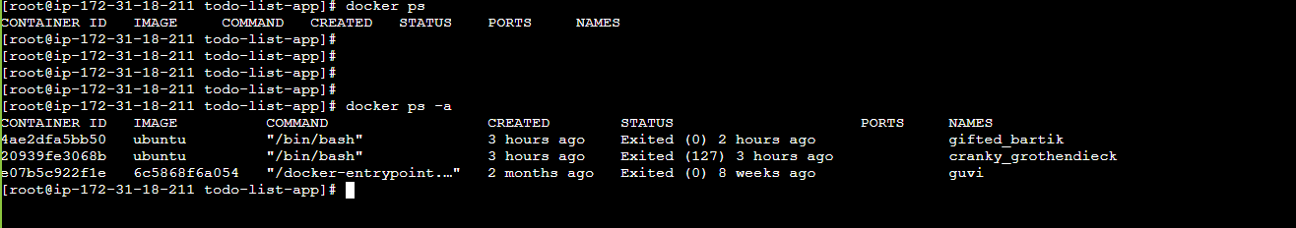

**Create a container from image :**

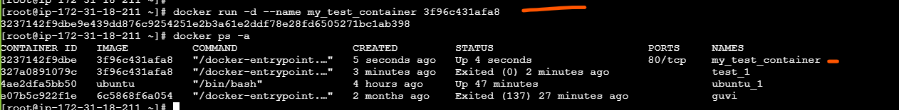

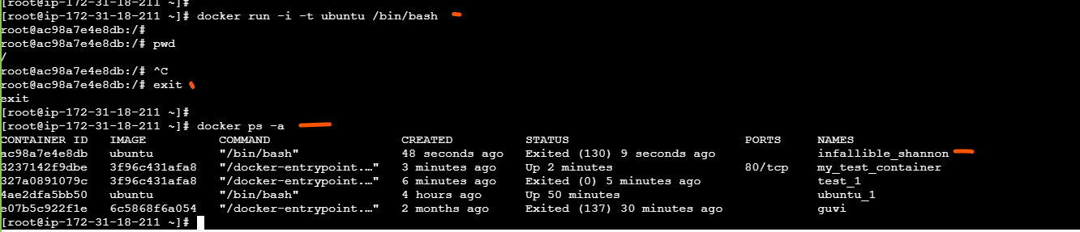

**Start / Stop Containers :**

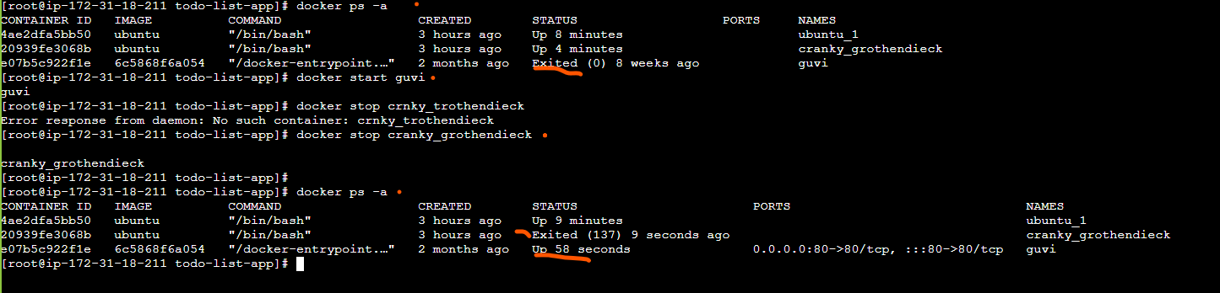

**Pause / Unpause Containers :**

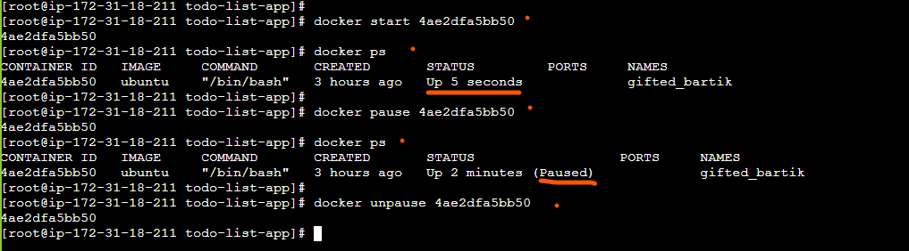

**Rename / Restart Containers :**

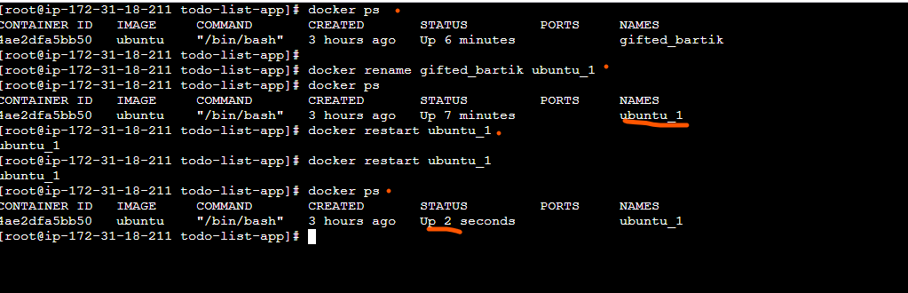

**Docker stats command**

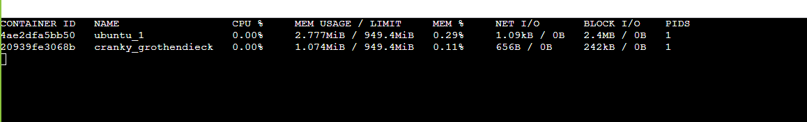

**Docker inspect command**

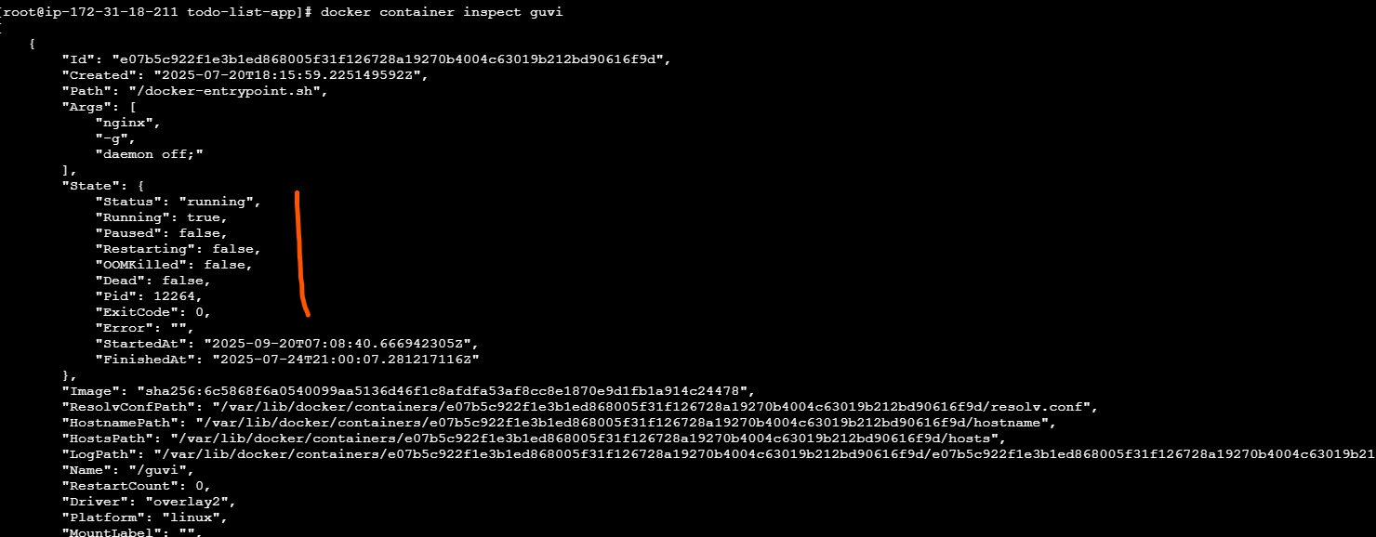

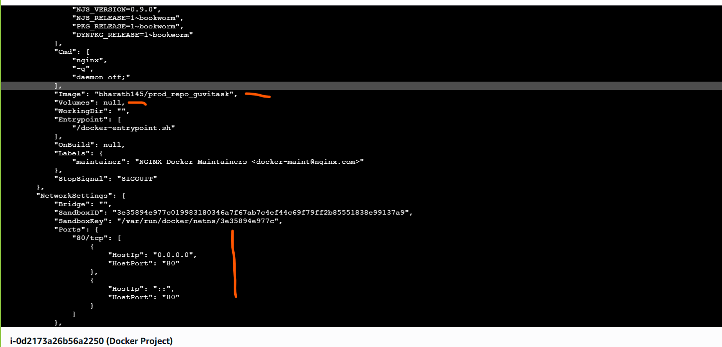

**Docker logs and docker kill command**

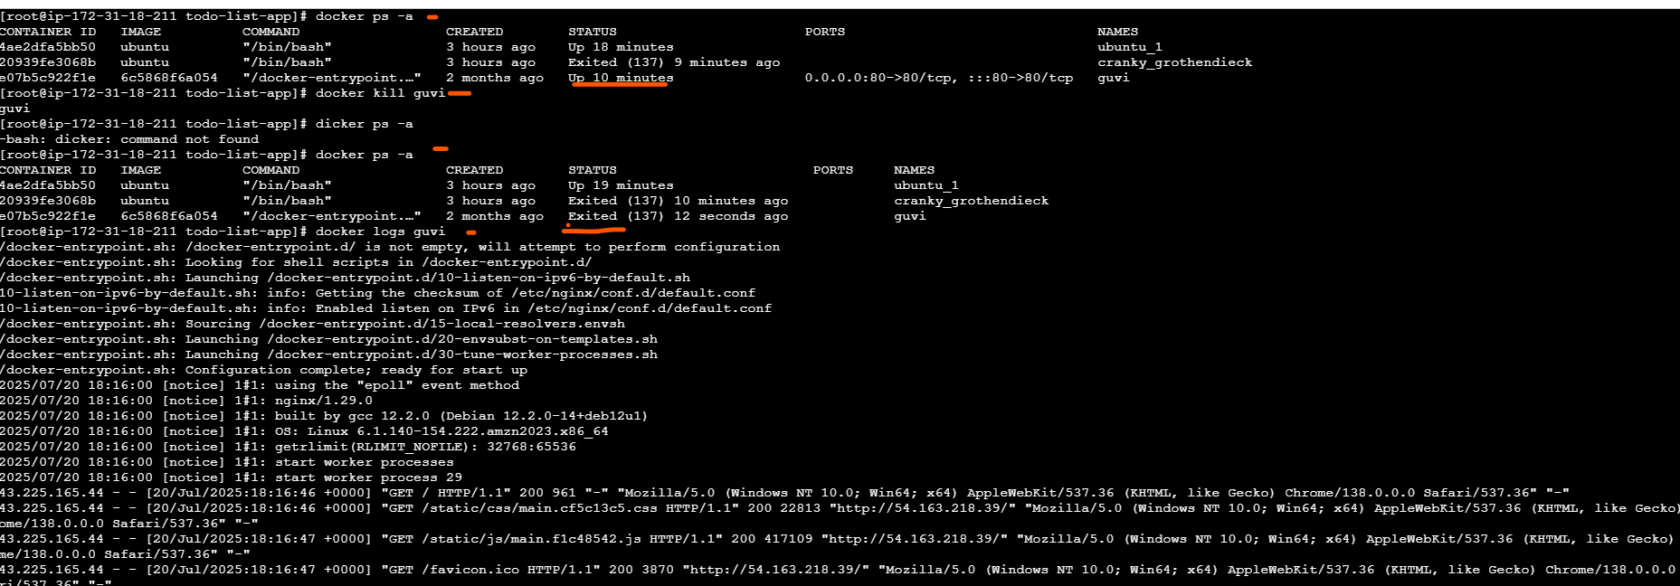

**Docker remove container :**

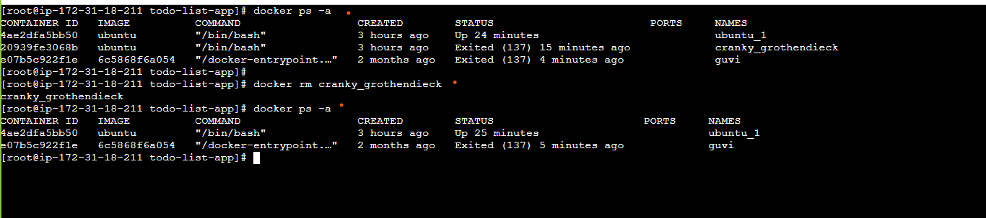

**Docker Volumes :**

**Create a Volume and mount to container and verify its mounted:**

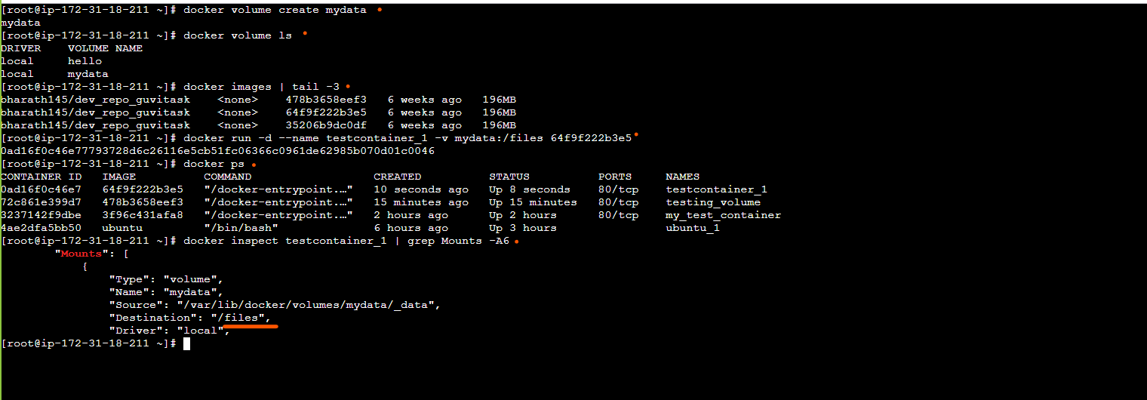

**Removing a Volume**

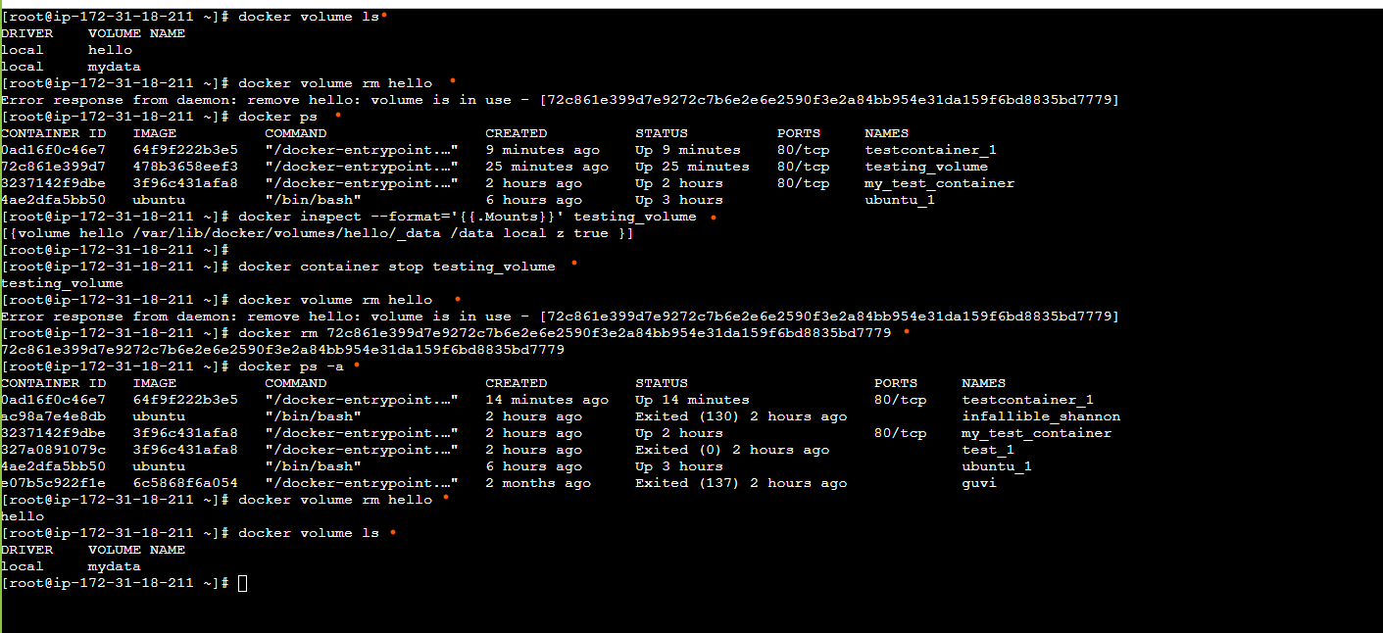

**Docker Network :**

**Create Docker Network**

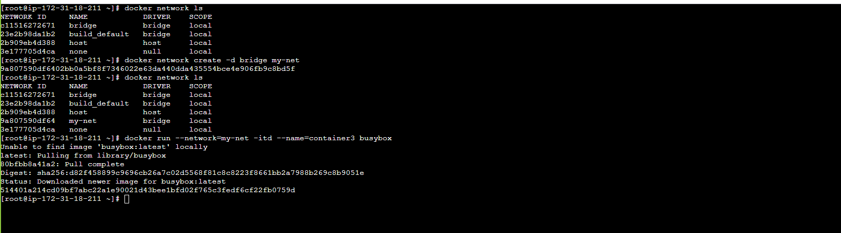



**Docker Connect Network**

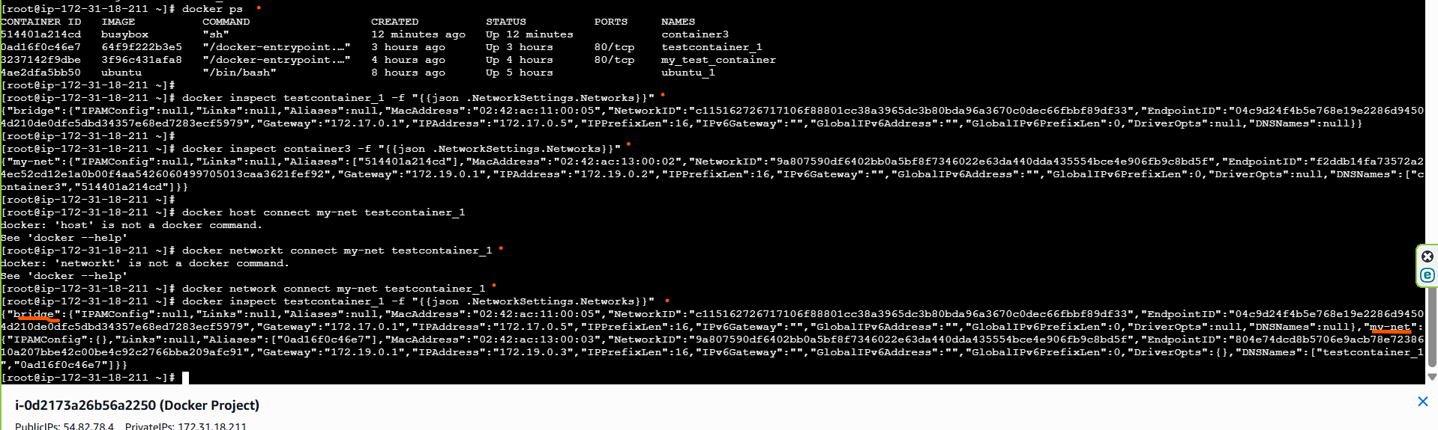

**Docker Disconnect Network and remove network**

